1. WAP to traverse Array list add the following elements 3,17,6,9,7.

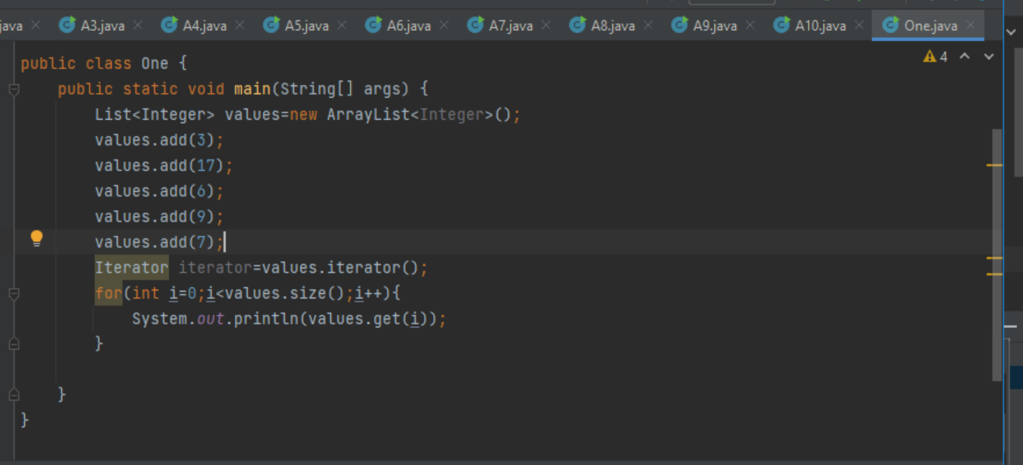

OUTPUT:

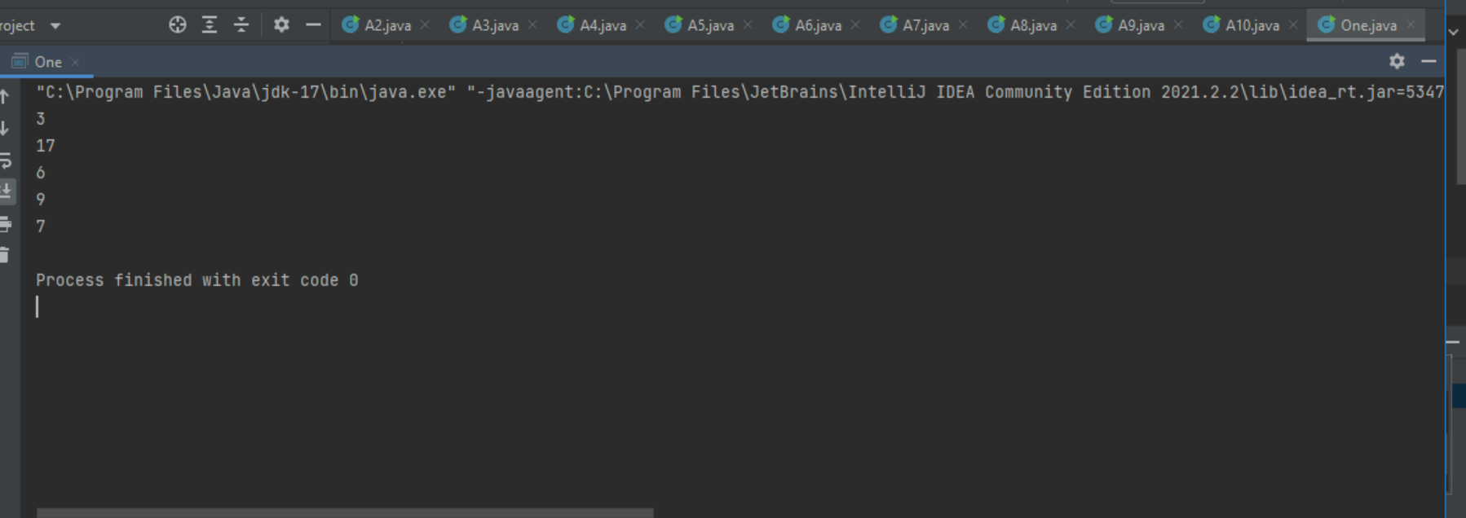

2.Wap to traverse a hashset add following elements 3,17,6,9,7.

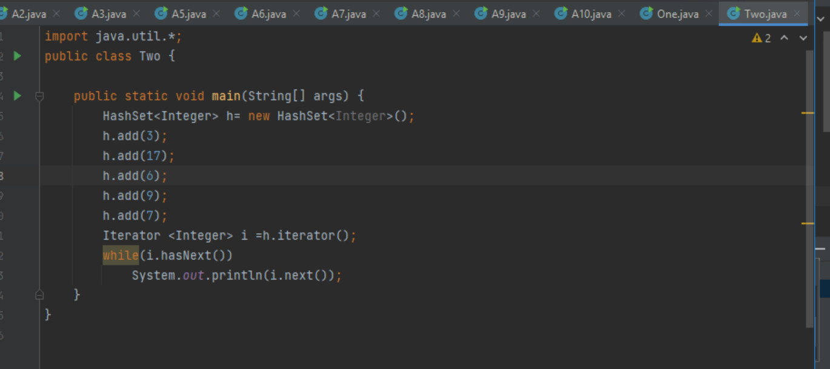

OUTPUT:

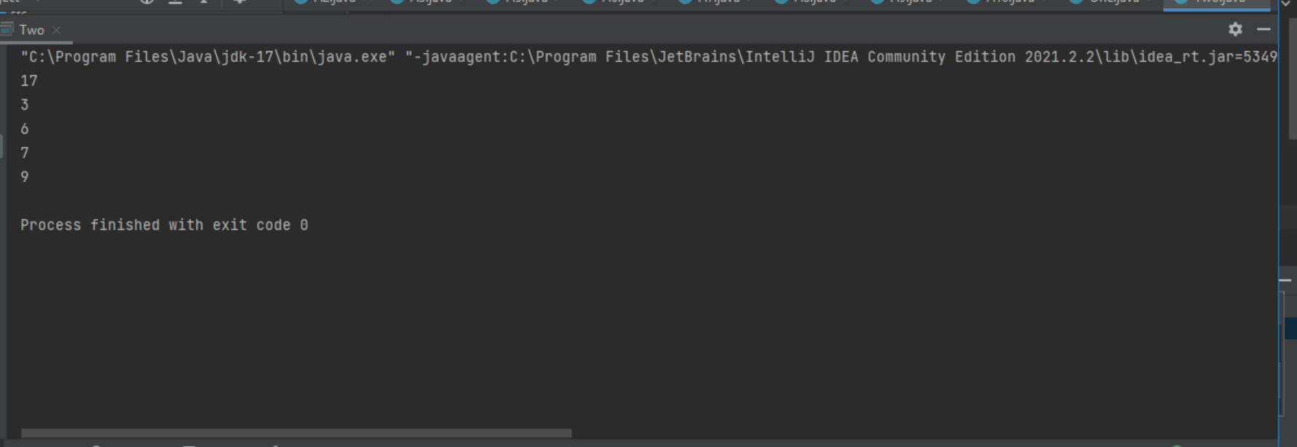

3.WAP to check if element exists or not, value will be Mumbai, Pune, Delhi, Indore, Lucknow check the value of Indore is present or not using array list and linked list.

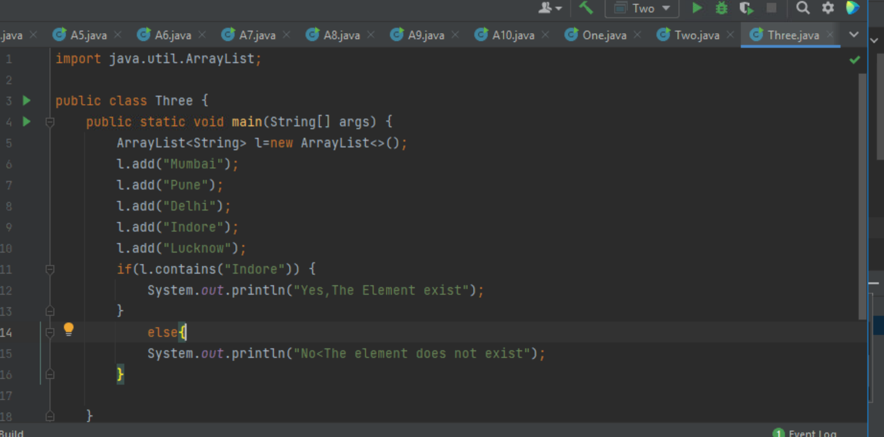

OUTPUT:

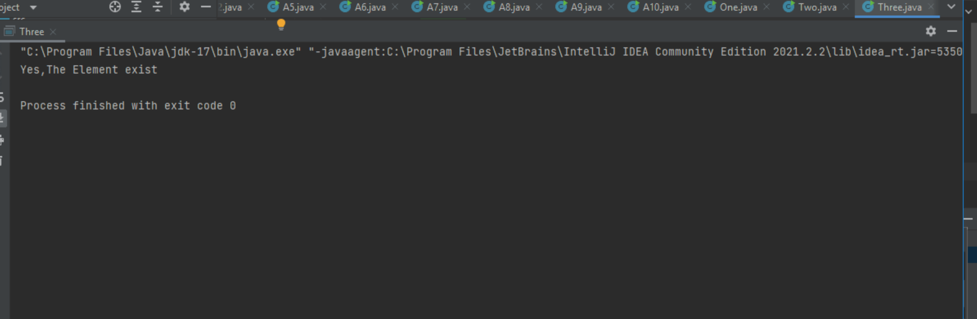

4.WAP to find the length of the Hash set value will be Mumbai, Pune, Delhi, Indore, Lucknow.

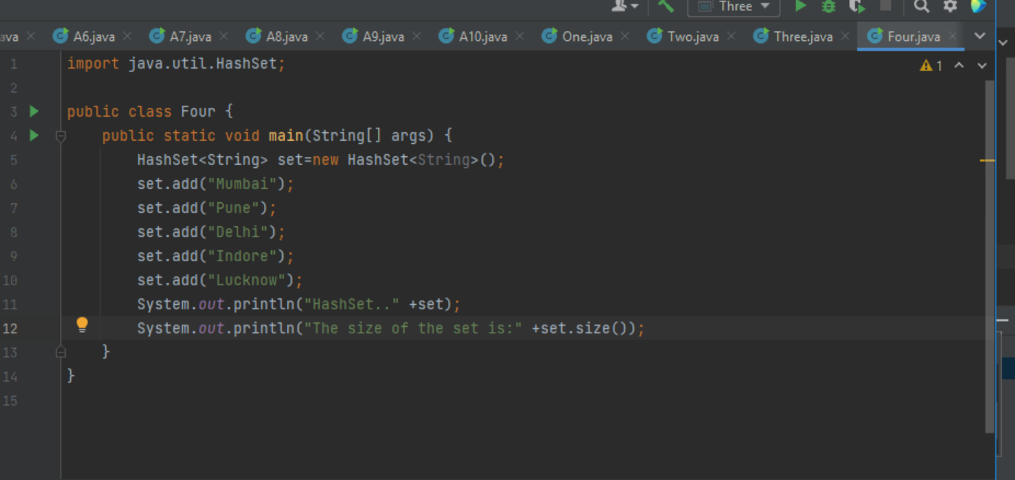

OUTPUT:

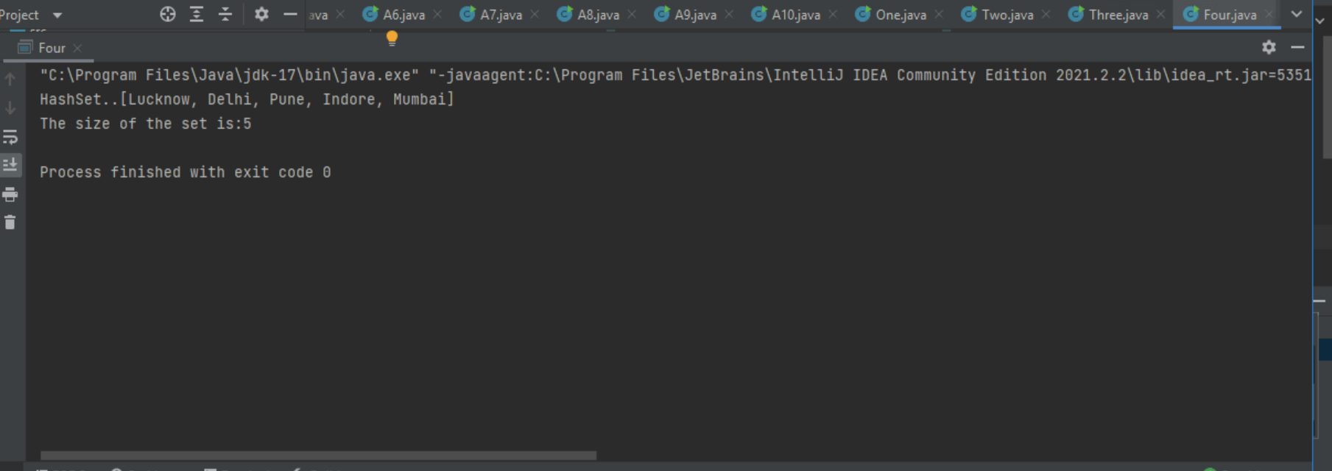

5. WAP to get the size of vector elements 2,5,7,8,10 value in it.

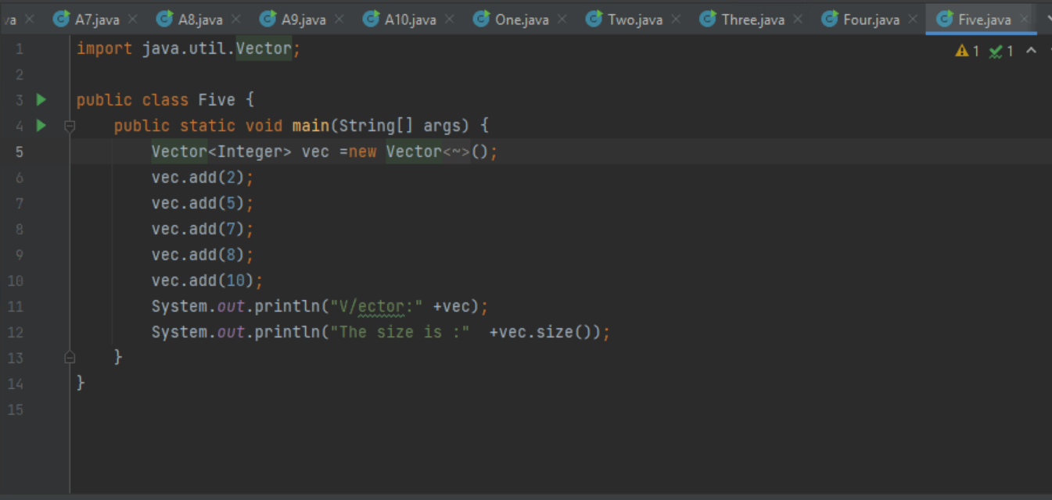

OUTPUT:

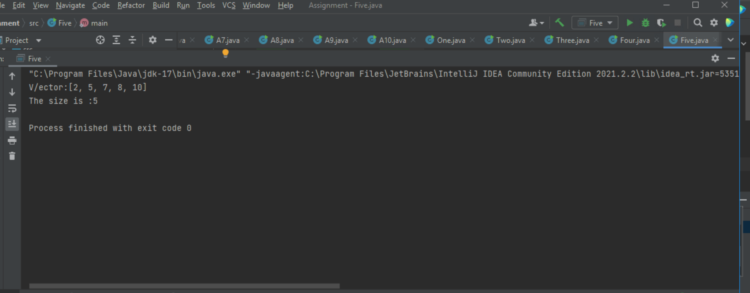

6.WAP to remove element from the array list, LinkedList.

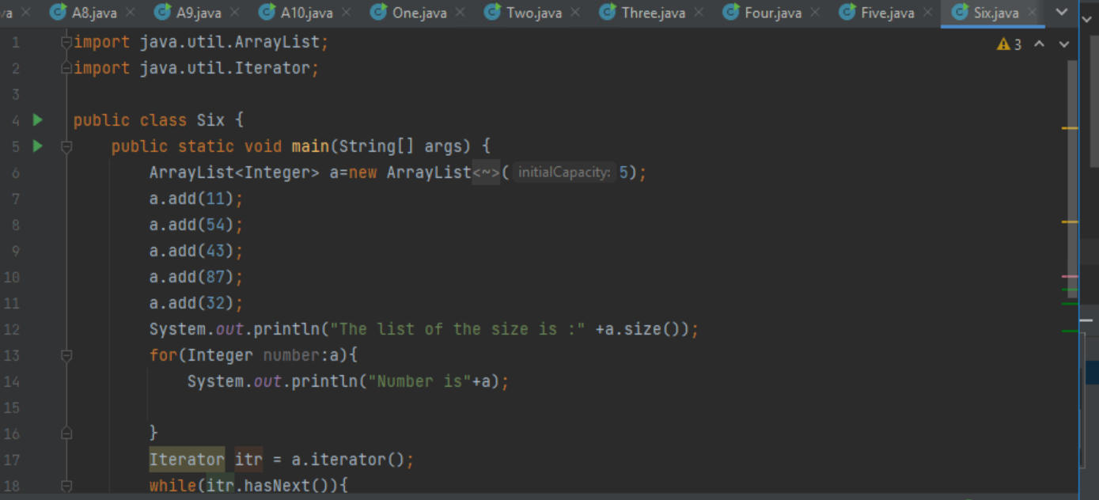

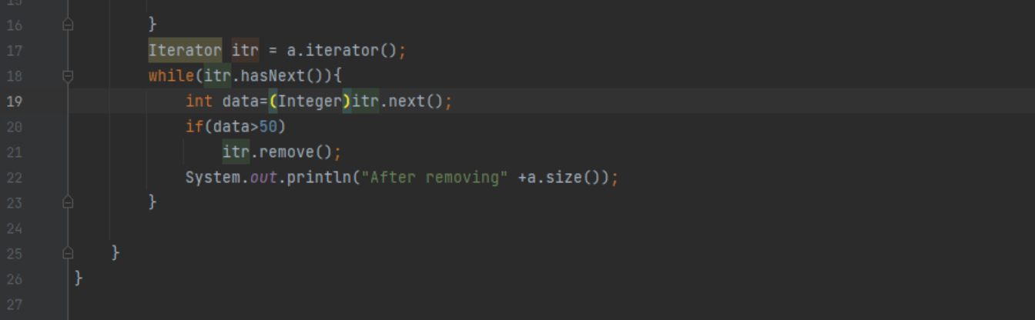

OUTPUT:

